母親節快樂
Happy Mother’s Day
Wah!  It is a shooting star!!  Wish come true!  Ling, Ling, Ling,,,,,, Cell phone is ringing! | 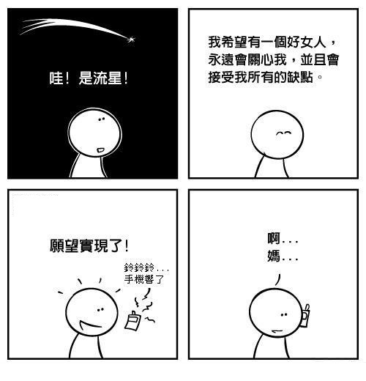  Download from email: Unknown comic author | I wish to meet a good woman who cares about me and accepts all my flaws.  Ahhh!!  Hi, Mom!!
BR from your Chinese School Principal S. Chyi
祁沁萍敬上
2012/5/13

